**DAILY ONLINE ACTIVITIES SUMMARY**

|  |  |  |  |  |  |  |  |  |
| --- | --- | --- | --- | --- | --- | --- | --- | --- |
| **Date:** | 21/05/2020 | | | | | **Name:** | RIYA C.P | |
| **Sem & Sec** | IV B | | | | | **USN:** | 4AL18CS070 | |
| **Online Test Summary** | | | | | | | | |
| **Subject** | | Microcontroller and Embedded Systems | | | | | | |
| **Max. Marks** | | 30 | | **Score** | | | 15 | |
| **Certification Course Summary** | | | | | | | | |
| **Course** | Python for Machine Learning | | | | | | | |
| **Certificate Provider** | | | Greatlearning academy | | **Duration** | | | 5.0 hours |
| **Coding Challenges** | | | | | | | | |
| **Problem Statement1:** Write a C program to implement SRTF process scheduling. Input: A set of processes with their burst time and arrival time Output: The processes scheduled based on the arrival time and a smaller burst time.  **Problem Statement2:** Write a C program to construct a singly linked list by removing duplicate elements in the sorted linked list Description: Take a sorted list and traverse the list. Compare the current node element with next adjacent node. If it is same then delete second element, if not retain. Finally print the resulting list. Sample output: Given list {1,2,2,3,3,3,4} Resulting list{1,2,3,4} | | | | | | | | |
| **Status: Executed** | | | | | | | | |
| **Uploaded the report in Github** | | | | | YES | | | |
| **If yes Repository name** | | | | | Lockdown-coding | | | |
| **Uploaded the report in slack** | | | | | YES | | | |

**Online Test Summary**: 18CS44 test was scheduled from 10:00 am t0 10:30am .The portion for the IA was 1st module there were 30 questions and the time assigned was 30 minutes the questions were mcq type.

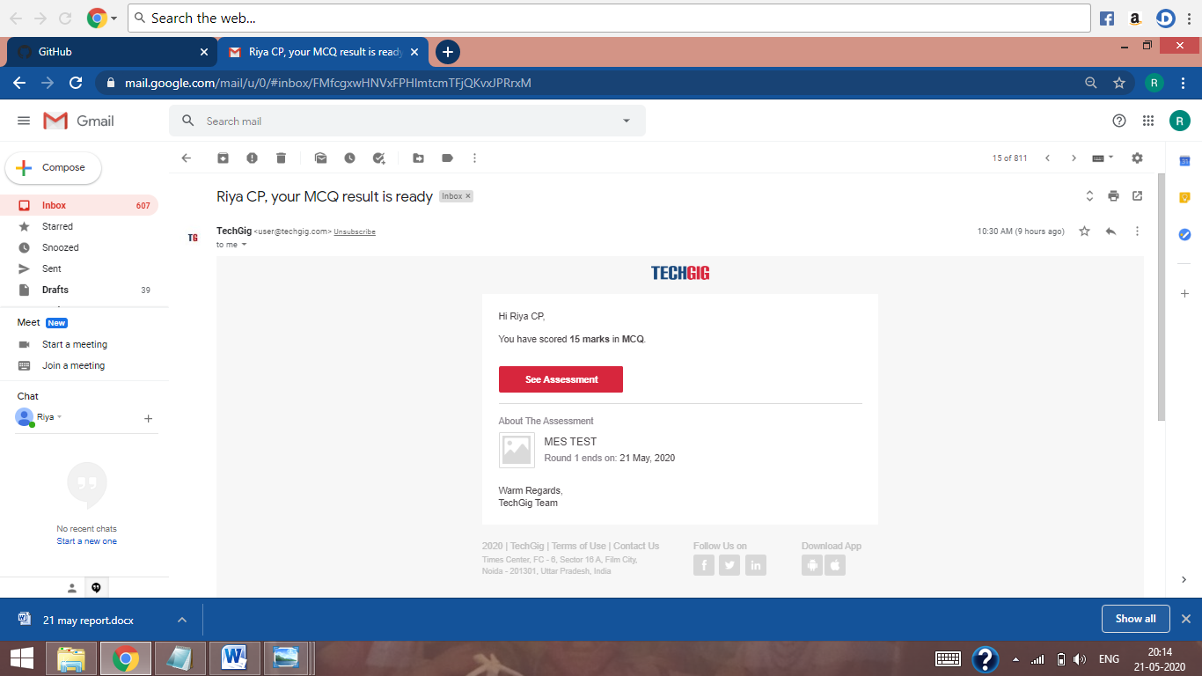

The above snap shot is the completion of the test and the marks allotted.

**Online Course Summary**: In today’s session I have learnt about conditional statements used in python like if, else, elseif (elif) statements. After that I came to know about loops like for, while, Nested loops and also some functions like user defined function how it can be used in python and the functions like lambda, filter, map, reducer and accumulator.

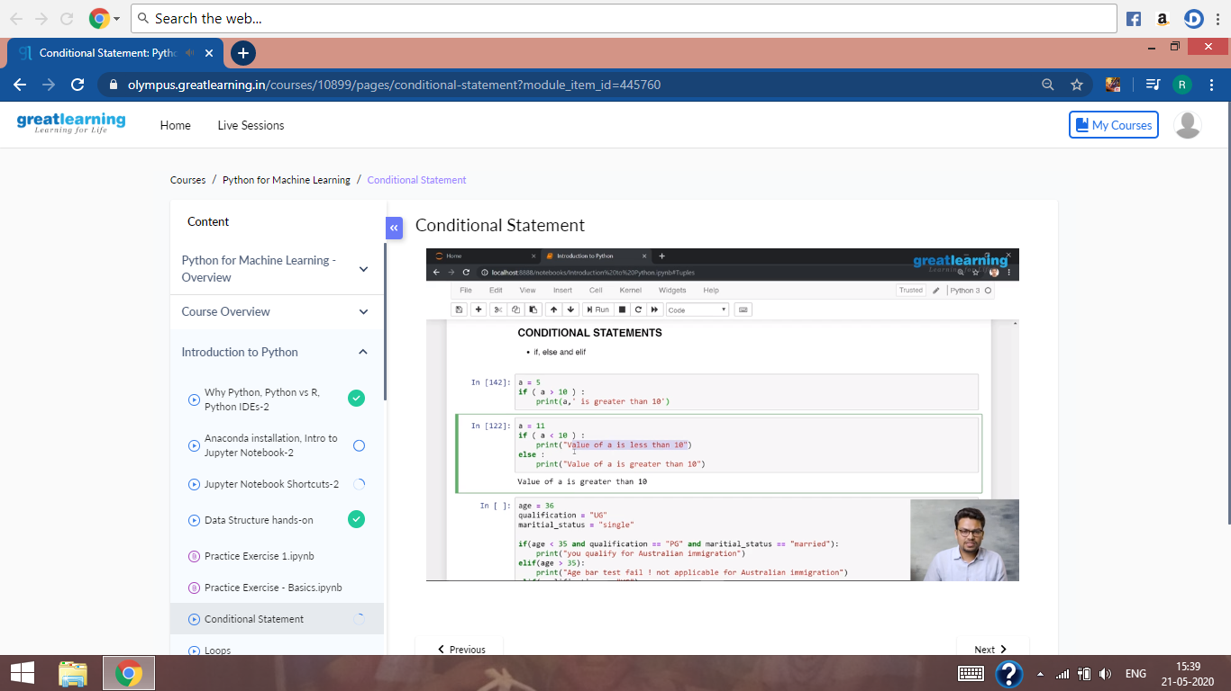

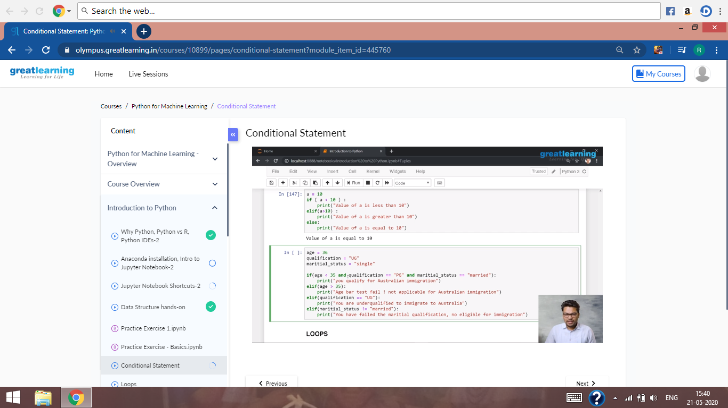

These are the snapshots of today’s session.

**Online Coding Summary:** Today I had received one program from prof. Merlyn Mathias CSE Dept. and the other from prof.Harshitha CSE Dept The programs is mentioned above in the coding challenges (pg.01). I have also uploaded it to my Github repository.

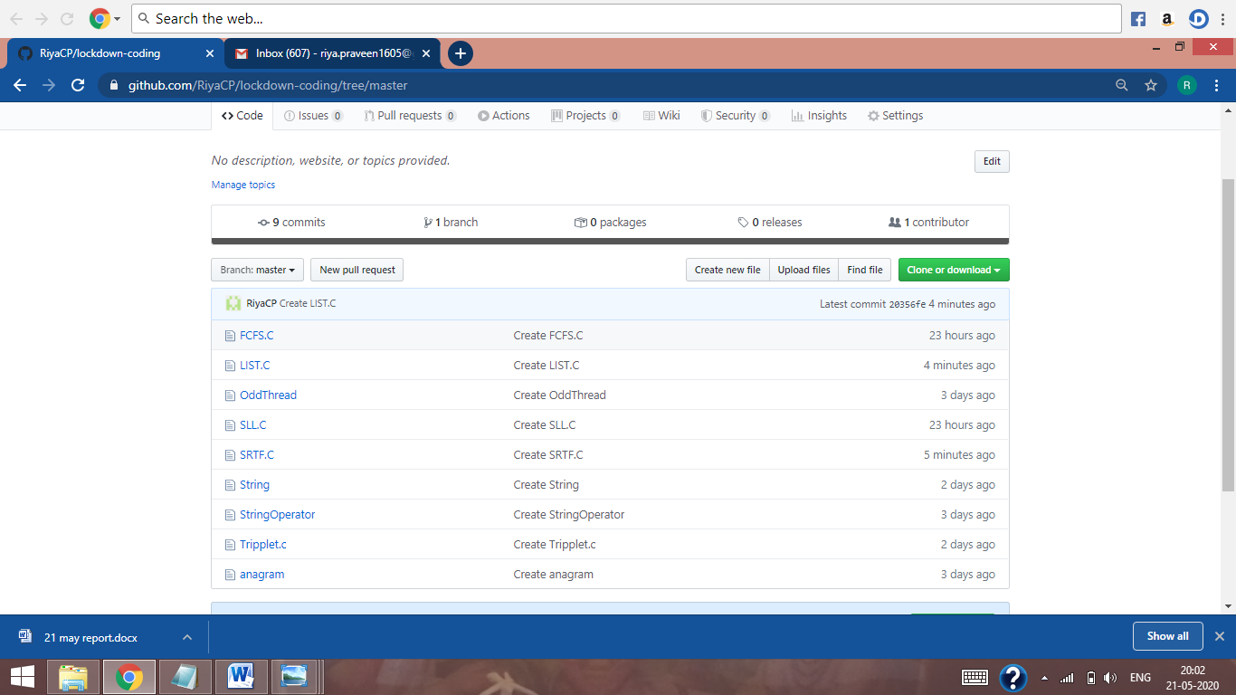

It is the snap shot of my repository were I have uploaded the code. File name is list.c and SRTF.c